Nick Fracaro and Gabriele Schafer, Artistic Directors
www.intlculturelab.org
info@intlculturelab.org
718-834-4542

CALL FOR PROPOSALS

5th Annual (REDUX)
CONEY ISLAND RITUAL CABARET FESTIVAL
Fri-Sun, March 31, April 1 & 2, 2023

Deadline: February 1

For questions, contact info@intlculturelab.org

International Culture Lab is calling for proposals from performance artists, actors, musicians, dancers, puppeteers, performers from the variety arts, and beyond... to present
an original performance between 5 and 15 minutes in length.

THE HISTORY OF CONEY ISLAND RITUAL CABARET is informed by dancer/choreographer Tatsumi Hijikata who co-originated butoh in 1960’s in an effort to defy and subvert authority, including conventional notions of dance, thereby seeking transformation – on the personal, societal and human level. Hijikata embraced the zeitgeist of Tokyo’s underground and the Europe-influenced avant-garde arts scene comprised of neo-Dadaism, Fluxus, German Expressionism, Surrealism, and Existentialism. During the day, he trained his dancers by inventing body rituals towards a revolutionary dance form. At night the group then experimented with bringing their exploration into the competitive marketplace of cabaret/burlesque. Inspired by this historical reference, in 2016 ICL founded a butoh, theatre and performing arts festival at Coney Island USA. After three years of directing ensemble workshops and performances for the Festival, Mexico-based Diego Piñón (of Body Ritual Movement) coined the term Ritual Cabaret for work that sought to marry ritualistic physical theater with cabaret, burlesque and sideshow on the CIUSA stage.

We would like to challenge you to deconstruct and reinvent your particular art form, whatever it might be. If the goal is TRANSFORMATION – of the self, of society, of humanity – what will it take to bring this about? Is it possible to invent a new genre? What is Ritual Cabaret to you?

Selected acts will perform for one night and will receive:
– $50 per one-person act / $100 for acts with more than one performer
– Full technical support
-- One-hour technical rehearsal in the performance space
– Photo and video documentation of the performance

Note:
- We are open to installations and durational work but would ask you to outline how it can best be framed as part of or alongside the Festival evenings.
- The Freak Bar – the lobby and intermission area – also holds potential for the above.
- We are able to host aerial performances.
- The theatre is accessible, and we encourage all levels of ability to apply.
- ICL DOES NOT ALLOW THE USE OF ANIMALS, DEAD OR ALIVE.

Co-Artistic Directors: Nick Fracaro and Gabriele Schafer
www.intlculturelab.org
info@intlculturelab.org
718-834-4542

CONEY ISLAND RITUAL CABARET FESTIVAL
APPLICATION FORM

Please send application as a single file (docx or pdf) and email it to info@intlculturelab.org with the words “CIRC Festival App” in the subject line.

Number of artists in piece:
Name(s) of artist(s):
Stage name(s) (act billing):
Contact phone:
Contact email:
Length of piece:
Title/subtitle of piece:
Bios of individuals (or ensemble) for the program (maximum 75 words):
Social media:

(For the following, word counts are not strict but suggested to help guide you as to how much information we think we need.)

1) WHO ARE THE ARTISTS? (250 words max.)
Tell us a bit about who you are and what work you've done before. We're interested in your experience and what matters to you as an artist.

2) WHAT DO YOU WANT TO DO AT THE CIRC FESTIVAL? (450 words max.)
Tell us about the piece you want to do. What exactly happens on the stage? What artforms are you referencing/using, and how are you stretching them? What are the ideas you're exploring? We want to have a clear picture of what you're making, how it explores both ritual AND cabaret, and how it addresses “transformation on the personal, societal or human level.”

3) WHY DO YOU WANT TO PERFORM AT THE CIRC FESTIVAL? (250 words max.)
Tell us about what performing at the CIRC Festival is right for you. How will this help you develop as an artist? Why is your performance a good fit with the Festival? Why do you think we're the right platform/venue for you?

4) WHAT ARE YOUR TECHNICAL, LOGISTICAL AND ACCESSIBILITY REQUIREMENTS?
Please detail what sort of technical specifications you have, including lighting and sound needs, any special equipment, and anything else you need from us to do the piece. Below you will find specs. We will do our best to help you find anything else.

5) DO YOU HAVE ANY SUPPORTING DOCUMENTATION?
Materials that are useful include photos, video, audio, reviews, and artist websites. Please send as links rather than email attachments.

ABOUT THE SPACE
For more information about the venue visit www.coneyisland.com
What follows are specs and general information provided by Coney Island USA.

General plot

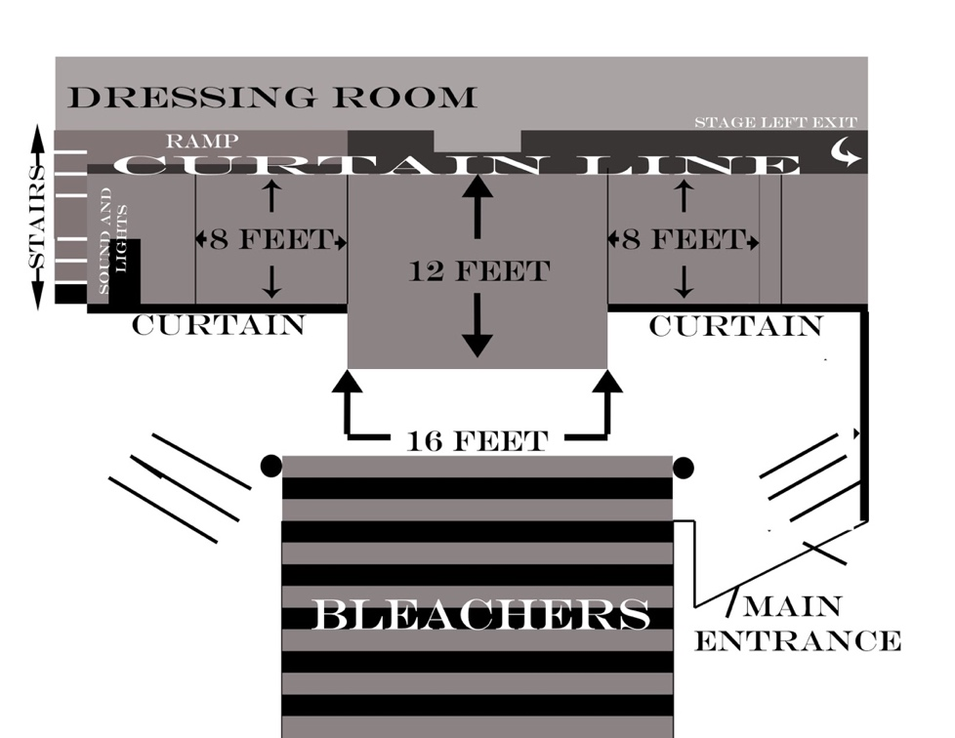

Venue Seating

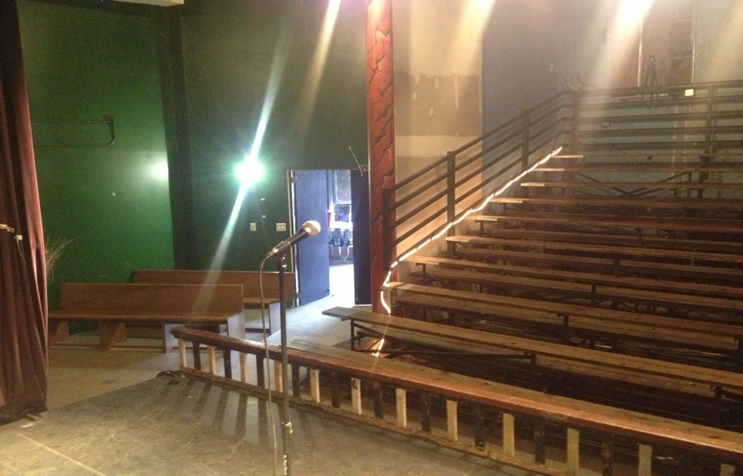

The theater legally seats 74 people. We have rising, bleacher-style seating, and floor-level bench seats.

Stage

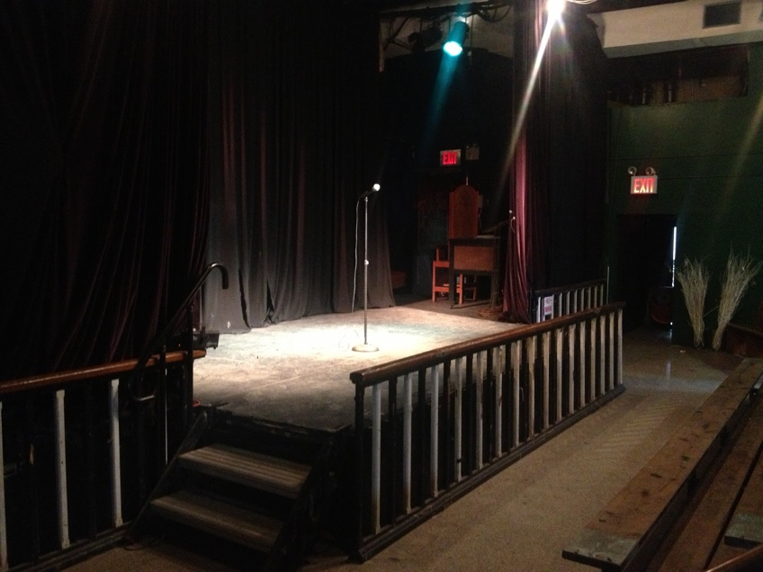
Our stage is 28 inches high, with a center area that is 12ft x 16ft. The wings are 8ft x 8ft. It is 13’7” to the top of the curtain line, and 14’9” to the ceiling. There are four aerial anchor points center stage. One center for single point, two approximately 34 inches apart for trapeze, audience-facing. There are proscenium curtains left and right creating a 16ft. aperture. There is an upstage curtain running the length of the stage left to right. There are multiple entry points stage left, right, and upstage center. There is a ramp and two-step stairs stage right, and two-step stairs stage left. There is a pass through behind the main curtain. Performers are able to move from stage left to stage right out of view of the audience.

Dressing Room

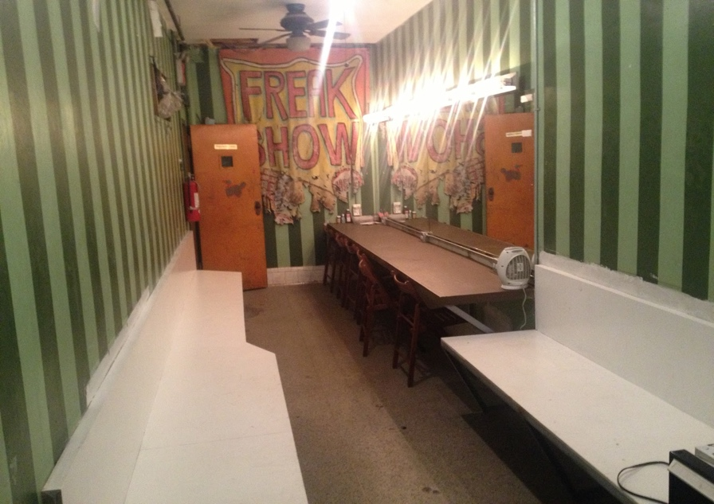
Our dressing room is located behind the theater. It enters the theater stage right. There is a full wall mirror to the counter and incandescent bulb lighting. The room is 7 feet wide by 15 feet long. There are benches mounted on both walls with storage space underneath. There is a 13 ft counter with a 4 foot by 13 foot wall mirror, two toilets and a shower. There is a small refrigerator with complimentary water.
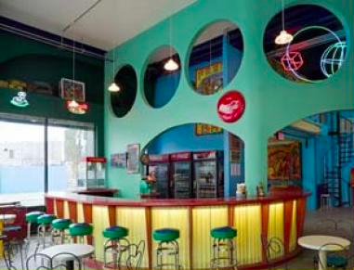
The Freak Bar

The Freak Bar is directly adjacent to the theater and serves as the lobby and intermission area. Each of the three evenings will have one intermission.

Lighting
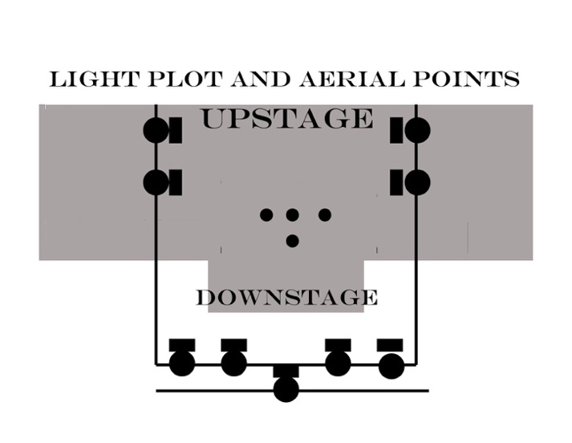
Our lighting rig is comprised of nine 500 watt Par 64 instruments. We do not have additional lighting at this time. Lights are set standard to provide the best coverage for most shows. Due to the limits of our lighting, we are unable to set complex lighting cues, or move instruments around. Lights can dim, and some crossfading can be manually triggered. Individual lights can be gelled for color.

Sound
CIUSA offers the following audio options:
16 channel soundboard with XLR and ¼” inputs, reverb settings and phantom power for condenser mic support.
XLR cables, ¼” cables, microphones, DI boxes and stick and boom stands.
Four wireless headset/ lavalier mics.
3.5mm input for ipod, iphone, ipad, mac, pc, mp3 player.
13” Macbook Pro with iTunes.
Fender guitar amp
Fender Bass amp
House Drum kit (fair condition--drummers should inspect prior to day-of)
ATTENTION: Any act involving blood, piercing, cutting, hook suspension, orifice insertion/expulsion or that involves bodily fluids of any kind must be brought to the attention of house management for review in advance of the performance.

Food, beverages, dairy products, meats, seafood, fresh animal parts, syrups, fresh fruit, vegetables, large volume powders, oils, petroleum-based substances or any other materials subject to spoiling, that are sticky, that coat or cover a large area of effect, are strictly prohibited. In many cases a simulation can be offered in substitution. Email patrick to discuss options.

Audience participation is acceptable in most cases. Non-consensual audience interaction is forbidden on any and all levels. This includes throwing objects, breaking objects that create sharp projectiles, spraying or shooting any substance into the audience,

COVID-19 PROTOCOLS

THE VENUE REQUESTS MASKS BE WORN WHENEVER POSSIBLE

FIRE PERFORMANCE
Fire Performances must be approved in advance of the show
The Sideshows By The Seashore venue hosts hundreds of fire performances each year. Our house performers are some of the best in the business. CIUSA maintains stringent guidelines and policies for fire performance in our space. We strictly follow the rules and regulations set forth by the FDNY and in accordance with the Certifications of Fitness for fire performance. Any performer using fire in our venue must possess FDNY certification. Use of fire or other dangerous performances will be subject to management discretion. Performers planning to use fire in their performances should notify Coney Island USA as far in advance as possible. (At least one week is preferred) Coney Island USA reserves the right to interview any fire performer booked to perform in our space. Fire performers are expected to provide a clear description of the details of their performance, including tools, fuel types, emergency protocols and demonstrate basic fire safety knowledge and preparation. Coney Island USA reserves the right to stop any performance at any time if deemed hazardous by management. A certified fire guard will be onsite for every show.

